**//WAP in Joomla to create Costum Modules on Website.**

Step 1 - Select Site Modules

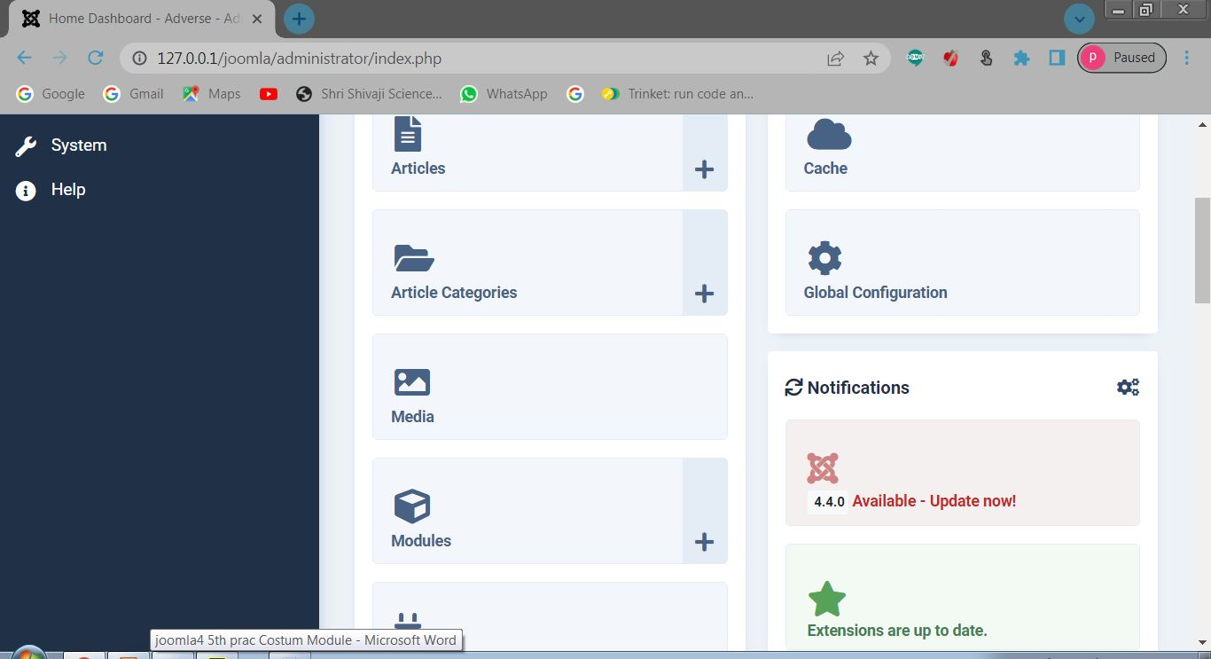

Step 2 - Select New Option

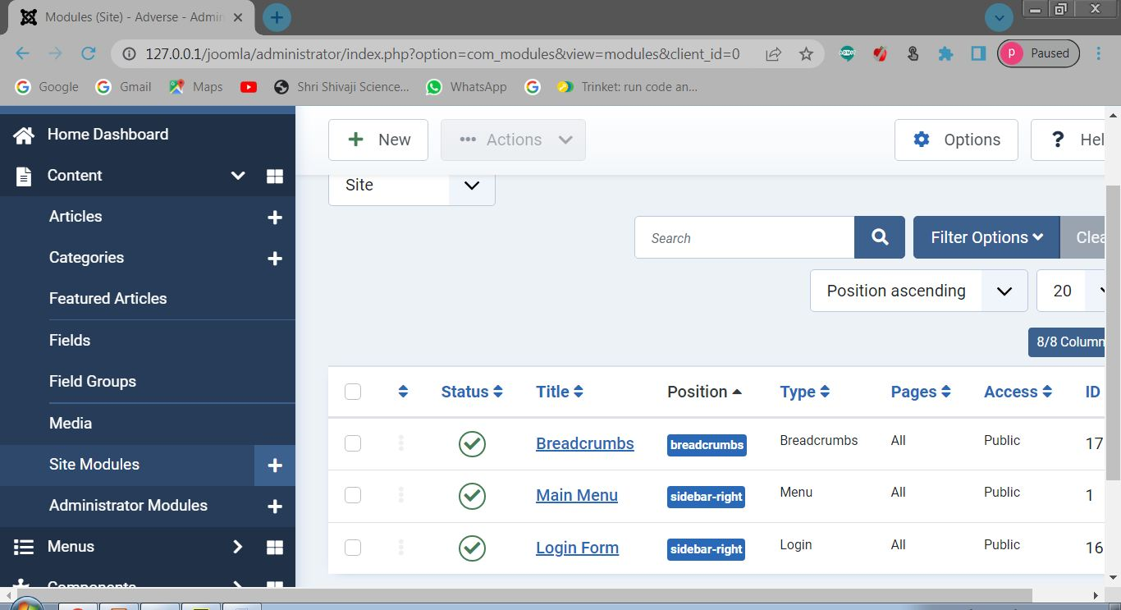

Step 3 - Select Custom

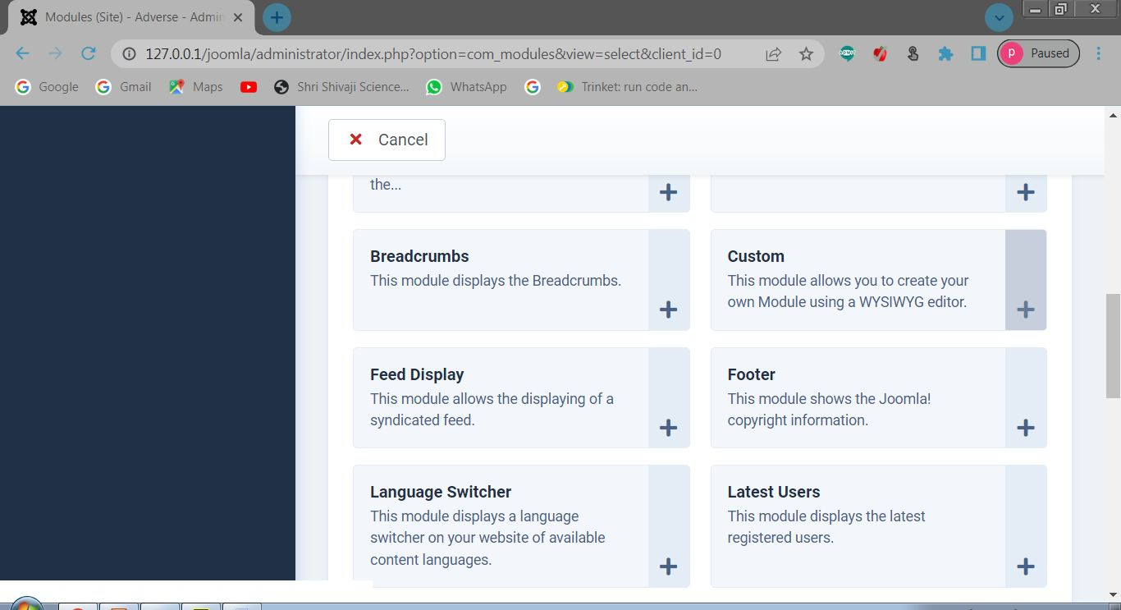

Step 4 - Create Modules

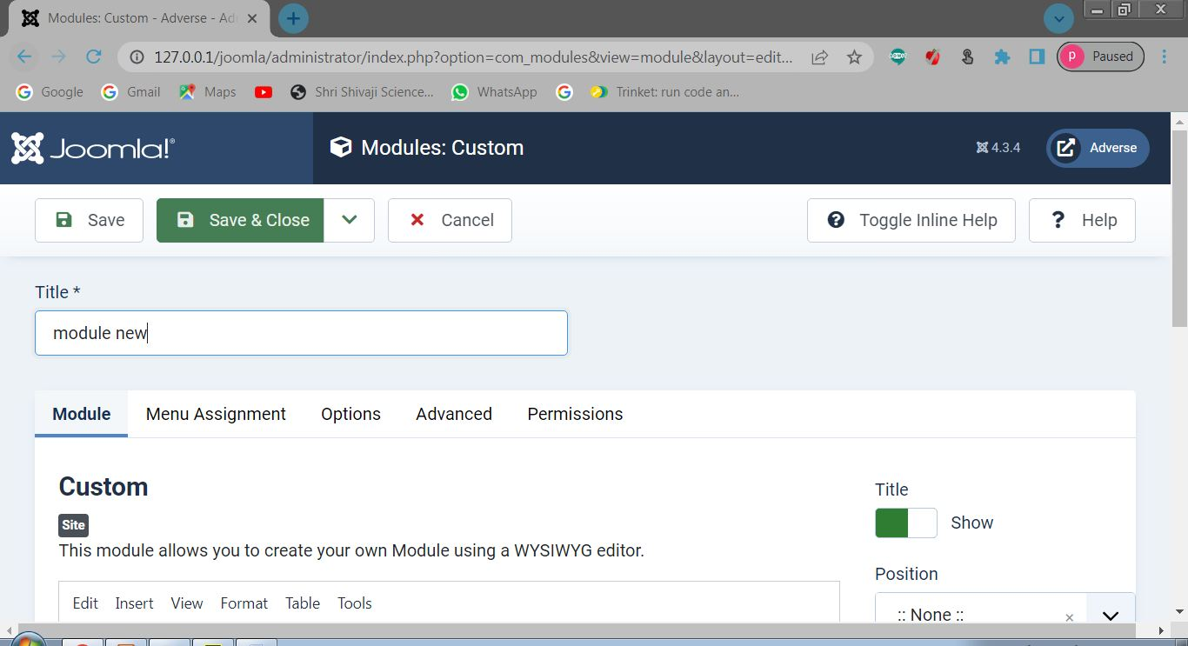

Step 7- Front End (Menu Created)

